American International University-Bangladesh (AIUB)  
Department of Computer Science  
Faculty of Science &Technology (FST)  
Spring 22 23

Section: K  
Software Quality Assurance and Testing

Laundry Express

A Report submitted

By

|  |  |  |
| --- | --- | --- |
| SN | Student Name | Student ID |
| 1 | Ishtiak Ahmed | 20-43553-1 |
| 2 | Md. Ahsanul Mostakin | 19-41342-3 |
| 3 | Ifthekhar Ahmed Tanjim | 19-40508-1 |
| 4 | Forhad Ali Emon | 20-44178-2 |

Under the supervision of

Mohammad Arifur Rahman

Assistant Professor, Dept of CS

Software Test Plan

for

<Laundry Express>

Version 1.0 approved

Prepared by <Ishtiak Ahmed>

<AIUB>

<28/04/23>

**Checked By Industry Personnel**

Name: Partha Roy

Designation: Project Manager

Company: Laundry Express

Sign:

Date: 02/05/23

Table of Contents

Revision History 3

1. TEST PLAN IDENTIFIER: RS-MTP01.3 3

2. REFERENCES 3

3. INTRODUCTION 3

Background to the Problem 3

Solution to the Problem 4

4. REQUEIREMNT SPECIFICATION 4

4.1 System Features 4

4.2 System Quality Attributes 4

4.3 System Interface 5

4.4 Project Requirements 5

5. FEATURES NOT TO BE TESTED 5

6. TESTING APPROACH 5

6.1 Testing Levels 5

6.2 Test Tools 6

6.3 Meetings 6

7. TEST CASES/TEST ITEMS 6

8. ITEM PASS/FAIL CRITERIA 7

9. TEST DELIVERABLES 7

10. STAFFING AND TRAINING NEEDS 8

11. RESPONSIBILITIES 8

12. TESTING SCHEDULE 8

13. PLANNING RISKS AND CONTINGENCIES 9

14. APROVALS 9

# Revision History

|  |  |  |  |
| --- | --- | --- | --- |
| Revision | Date | Updated by | Update Comments |
| 0.1 | 2023.04.29 | Ishtiak Ahmed | First Draft |
| 0.2 | 2023.04.30 | Md. Ahsanul Mostakin | Second Draft |
| 0.3 | 2023.04.30 | Ifthekhar Ahmed Tanjim | Third Draft |
| 0.4 | 2023.04.1 | Forhad Ali Emon | Fourth Draft |
| 0.5 | 2023.04.1 | Forhad Ali Emon | Fifth Draft |
| 0.6 | 2023.04.1 | Md. Ahsanul Mostakin | Sixth Draft |
| 0.7 | 2023.04.2 | Ishtiak Ahmed | Final Draft |
| 0.8 | 2023.04.2 | Ishtiak Ahmed | Revised |

# TEST PLAN IDENTIFIER: Laundry Express1.3

# REFERENCES

|  |
| --- |
| * A. S. Albader, "Ask4help Application," 2019. [Online]. Available: https://m.mu.edu.sa/sites/default/files/content/2019/10/Final%20report.pdf. |
| * R. Bandakkanavar, "Krazy Tech," 10 June 2021. [Online]. Available: https://krazytech.com/projects/sample-software-requirements-specificationsrs-report-airline-database. |
| * S. Nath, 2 November 2018. [Online]. Available: https://github.com/ProjectRecommend/docs/blob/master/design-docs/SRS_final.md. |
| * M. KUMWENDA, "Make use of_," 23 July 2021. [Online]. Available: https://www.makeuseof.com/reasons-why-you-should-never-use-xampp-on-production-server/. |

# INTRODUCTION

## Background to the Problem

Laundry has been part of history since humans began to wear clothes, so the methods by which different cultures have dealt with this universal human need are of interest to several branches of scholarship. Regular washing of clothes and bedding, helps to remove any bacteria, dirt, fleas, mites and other irritants or infection. Washing of clothes and bedding can help reduce the incidence of infectious diseases, such as diarrheal disease, respiratory infections, scabies and other skin infections. That’s why it is important to have a good laundry clothes. But in modern world since everyone is busy it is hard to find time an easy way to do laundry. It is pain to do laundry on own or to take to the laundry store. Most of the time the customer needs to stand in line and wait for hours to do their laundry in laundry store. Thus, this manual labor is more time consuming.

## Solution to the Problem

‘Laundry Express’ is an online laundry service where the user can easily do their services through online just a few clicks. User can easily view the services that the system offers and view the prices of each item for each service. After choosing the services and adding the items (example: clothes, bedsheets etc.) the user can confirm their order. Confirming the order the user can make payment through mobile banking, credit card. After the bill is made our delivery staff will be at the users’ doorstep to collect the items.

Anyone will be able to visit the webpage in order to check and the services that it offers. But in order to enjoy the services a user must create an account. Each user will have a profile to keep track of their orders and also online payment system. The order of each user will be notified through notification system. At the end of the service users can rate the service and comment for further future improvement.

# REQUEIREMNT SPECIFICATION

## System Features

For User:

1. **Software login**

**Functional requirements**:

* 1. System will allow users to login with their given username and password.
  2. The login credentials (username and password) will be verified with database records.
  3. If the login successful, the service page of the user account will be displayed.
  4. If the user misses any of the box to be filled username or password it will give message to fill the box.
  5. The password of the user must contain one upper case, lower case, number and special character.

**Priority Level:** High

**Precondition:** User must have valid username and password

1. **Service system**

**Functional requirements:**

* 1. System will allow the users to choose the services they want to do.
  2. Users will be able to add the product like: shirt, t-shirt, pant, bedsheet etc. in to their preferred services.
  3. Each product has their own prices into according to the services.
  4. Each time a product is added. The system will automatically calculate the total amount of product the and the total price to create order list.

**Priority Level:** High

**Precondition:** User must have an account.

1. **View Prices**

**Functional requirements:**

* 1. Any user will be able to able to view to the prices of the product in each service.
  2. Click in the designated service in order to view the price list.

**Priority Level:** Low

**Precondition:** N/A

1. **Profile**

**Functional Requirements:**

* 1. The users will be able to edit their profile.
  2. They will be able to edit their profile picture, names.
  3. From the profile users will also be able to change their username and password.

**Priority level:** Medium

**Precondition:** N/A

For Admin:

1. **Software login**

**Functional requirements**:

* 1. System will allow users to login with their given username and password.
  2. The login credentials (username and password) will be verified with database records.
  3. If the login successful, the service page of the user account will be displayed.
  4. If the user misses any of the box to be filled username or password it will give message to fill the box.
  5. The password of the user must contain one upper case, lower case, number and special character.

**Priority Level:** High

**Precondition:** User must have valid username and password

1. **CRUD Operation**

**Functional requirements:**

* 1. Add employee, company, branches.
  2. Delete employee, company, branches.
  3. Update employee, company, branches.

**Priority Level:** High

**Precondition:** N/A

1. **View Information**

**Functional requirements:**

* 1. View employee information. Joining date, salary etc.
  2. View customer information. Order, services etc.
  3. View company information.

**Priority Level:** Medium

**Precondition:** N/A

1. **Profile**

**Functional Requirements:**

* 1. The users will be able to edit their profile.
  2. They will be able to edit their profile picture, names.
  3. From the profile users will also be able to change their username and password.

**Priority level:** Medium

**Precondition:** N/A

For Employee:

**1 Software login**

**Functional requirements**:

* 1. System will allow users to login with their given username and password.
  2. The login credentials (username and password) will be verified with database records.
  3. If the login successful, the service page of the user account will be displayed.
  4. If the user misses any of the box to be filled username or password it will give message to fill the box.
  5. The password of the user must contain one upper case, lower case, number and special character.

**Priority Level:** High

**Precondition:** User must have valid username and password

1. **View Information**

**Functional requirements:**

* 1. System will allow to view customer information.
  2. It will allow to view customer services and order.
  3. It will allow to view delivery shifts and order.

**Priority Level:** High

**Precondition:** N/A

**3 Profile**

**Functional Requirements:**

* 1. The users will be able to edit their profile.
  2. They will be able to edit their profile picture, names.
  3. From the profile users will also be able to change their username and password.

**Priority level:** Medium

**Precondition:** N/A

## System Quality Attributes

1. **Performance:** The system should be able to very smoothly and efficiently to meet the users need.
2. **Availability:** The system should be available 24/7 with minimal downtime.
3. **Scalability:** The system should be able to handle an increasingly number of customers without compromising performance.
4. **Security:** The system should be protected from unauthorized access and any data breach.
5. **Reliability:** The system should be reliable and provide consistent results. Lists down the quality attributes that describes how well the system should perform.
6. **Usability:** The system should be easy to use, intuitive and user friendly.
7. **Maintainability:** The system should be designed in such a way it can easily be modified to meet changing customer needs.

## System Interface

* **Use Case Diagram:**

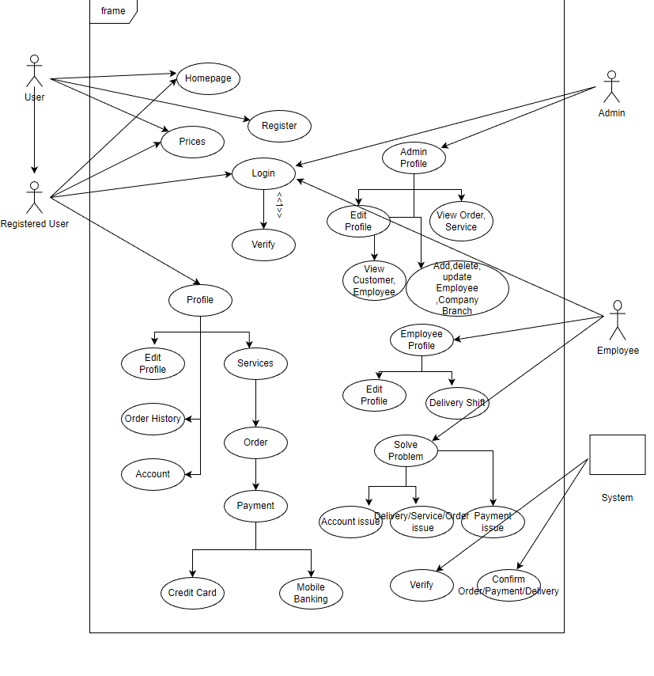

* **Class Diagram:**

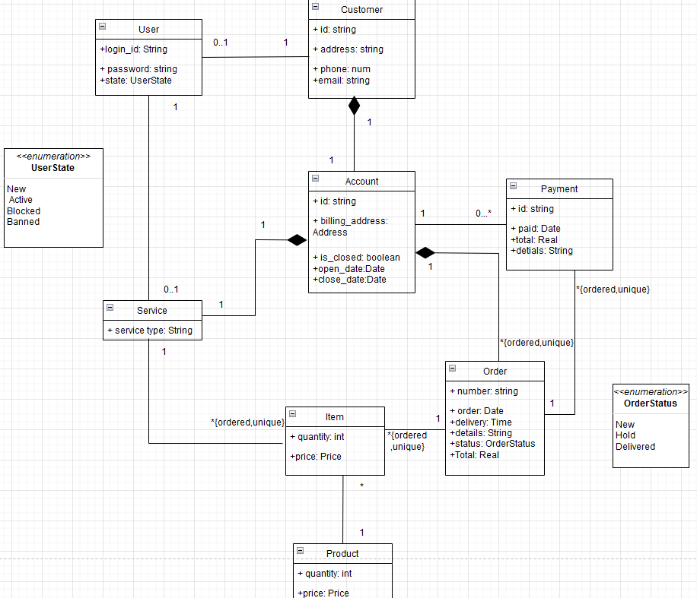

* **Activity Diagram:**

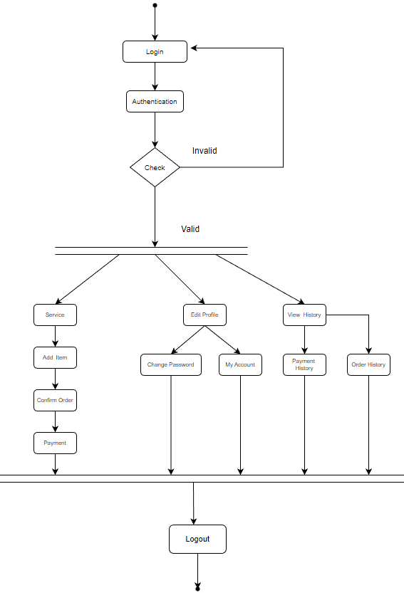

## Project Requirements

* This system was built on XAMPP as it is cross platform, open source and easy to set up tool. Thus, it is not recommended for production server for security reasons. There is no password for the database administration. Therefore, hackers can gain access easily. Anyone accesses to database can view and copy confidential users and company information. MYSQL can be access over a network. The local mail server is not also very secure. ProFTDP uses a known password. ProFTDP is the default (File Transfer Protocol) client used by XAMPP. Default password is set to ‘lampp’. Thus, user can easily access to web pages.
* The information of all the users will be stored in database that is accessible by the system. MYSQL will be used as SQL engine and database.
* User may access any devices that supports internet browsing capabilities and internet connect. User must have correct username and password in order to access their account.
* **Tools:** The system needs seleniumin performance for testing activities.
* **System Interface:** Any popular operating system will allow the use of a modern browser to view and download web pages.
* **User Interface:** Logical characteristics: The GUI of the product shall be designed in HTML/PHP, allowing multitude of different user access. The HTML design will remove most of limits of the access because every popular operating system has HTML viewing capabilities.

Aspects: The system shall have content that will be only viewable to the user if only they are logged in correctly. Also, there will be different types of users having different types of accessing/ viewing/modification privileges.

* **Operation:** The site shall allow authorized user to specifically do certain functionalities. The site shall allow different access permission depending on who the user is.
* **Hardware Interface:** An internet connection to allow the browser software interfaces to connect to the internet to access the files of the website.
* **Software Interface:**

Name: Mozilla Firefox

Mnemonic: Firefox

Specification number

Version number

Source

Purpose: To allow remote access of the website and downloading of files via the internet.

Name: Microsoft Internet Explorer

Mnemonic: IE

Specification number IE7, IE8

Version number: 7.0, 8.0

Source: Microsoft.com

Purpose: To allow remote access of the website and downloading of files via the internet.

Name: Apple Safari

Mnemonic: Safari

Version number: 5.0.2

Source: apple.com

Purpose: To allow remote access of the website and downloading of files via the internet.

Name:  Opera

Mnemonic: Opera

Version number: 10.62

Source: opera.com

Purpose: To allow remote access of the website and downloading of files via the internet.

Name: Google Chrome

Mnemonic: Chrome

Version number: 6

Source: google.com/chrome

Purpose: To allow remote access of the website and downloading of files via the internet.

# FEATURES NOT TO BE TESTED

* Order history.
* Price list in user profile.
* My reviews.
* Rating Star.
* Payment method.
* Admin profile

# TESTING APPROACH

## Testing Levels

* **Unit Testing:** It is done by the developer and approved by the development team leader. Individual components or units of the software with specific inputs are tested
* **System Testing:** It is performed by the test manager and development team leader with assistance from the individual developers as required. Tested the whole system to ensure it meets the design specifications. Programs will enter into System/Integration test after all critical defects have been corrected.

* **User Acceptance Testing (UAT):** It is performed by the real end users with the assistance of the test manager. After the System/Integration test is completed, the acceptance test will run in parallel with the prevailing manual process

## Test Tools

* Selenium: Selenium is a powerful open-source tool for automating web browsers. It is used to test the functionality of web applications on different browsers.

* Manual Testing: Manual Testing is a type of software testing in which test cases are executed manually by a tester without using any automated tools. The purpose of Manual Testing is to identify the bugs, issues, and defects in the software application. Manual software testing is the most primitive technique of all testing types and it helps to find critical bugs in the software application.

## Meetings

It took two weeks since the first draft and our team held meeting twice a week, every Monday and Wednesday.

Meeting occurred in Microsoft Teams

|  |  |  |
| --- | --- | --- |
| Meeting Date | Meeting Criteria | Objective |
| 17/04/23 | Analysis | o Functions analysis  o Work process analysis |
| 19/04/23 | Progress Evaluation | o How far the project is prepared  o Progress evaluation |
| 26/04/23 | Error Trends | o C o chacking the error trends and bugs |
| 27/04/23 | Revise The system | o Check the whole system  o Run the system  o Revise all |

# TEST CASES/TEST ITEMS

|  |  |  |  |  |  |
| --- | --- | --- | --- | --- | --- |
| Project Name: Laundry Express | | | Test Designed by: Ishtiak Ahmed | | |
| Test Case ID: FR_1 | | | Test Designed date: 02/05/23 | | |
| Test Priority (Low, Medium, High): High | | | Test Executed by: Ishtiak Ahmed | | |
| Module Name: Login Session | | | Test Execution date: 02/05/23 | | |
| Test Title: verify login with valid username and password | | |  | | |
| Description: Test website login page | | |  | | |
| Precondition (If any): User must have valid username and password | | | | | |
| Test Steps | Test Data | Expected Results | | Actual Results | Status (Pass/Fail) |
| 1. Go to the website 2. Enter username 3. Enter password 4. Click submit | Username: roy  Password: 123qw!@QW | User should login into the application | | As expected, | Pass |
| Post Condition: User is validated with database and successfully login to account. The account session details are logged in the database. | | | | | |

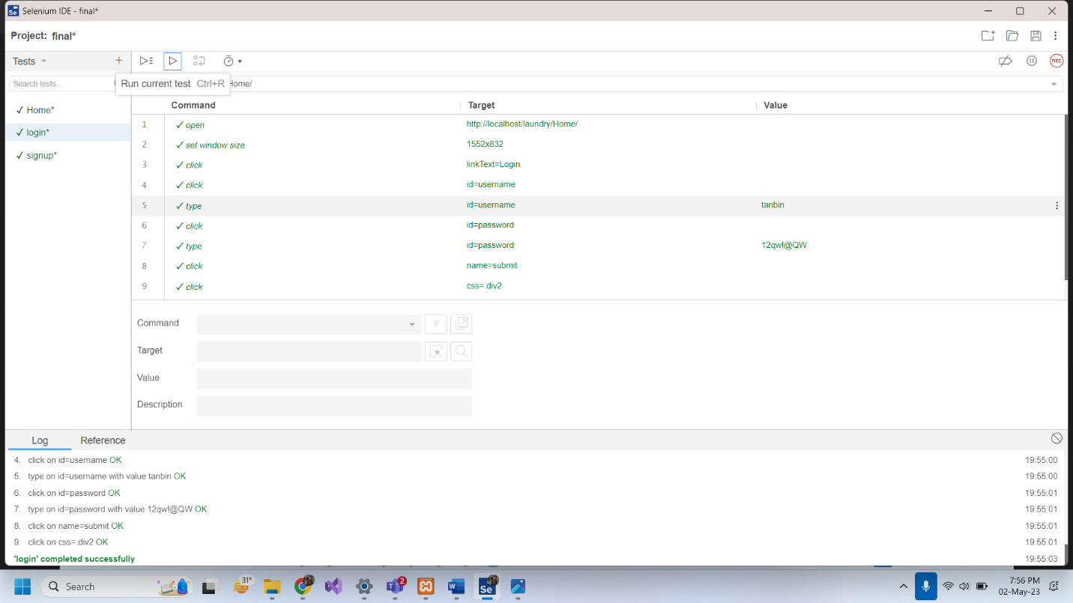

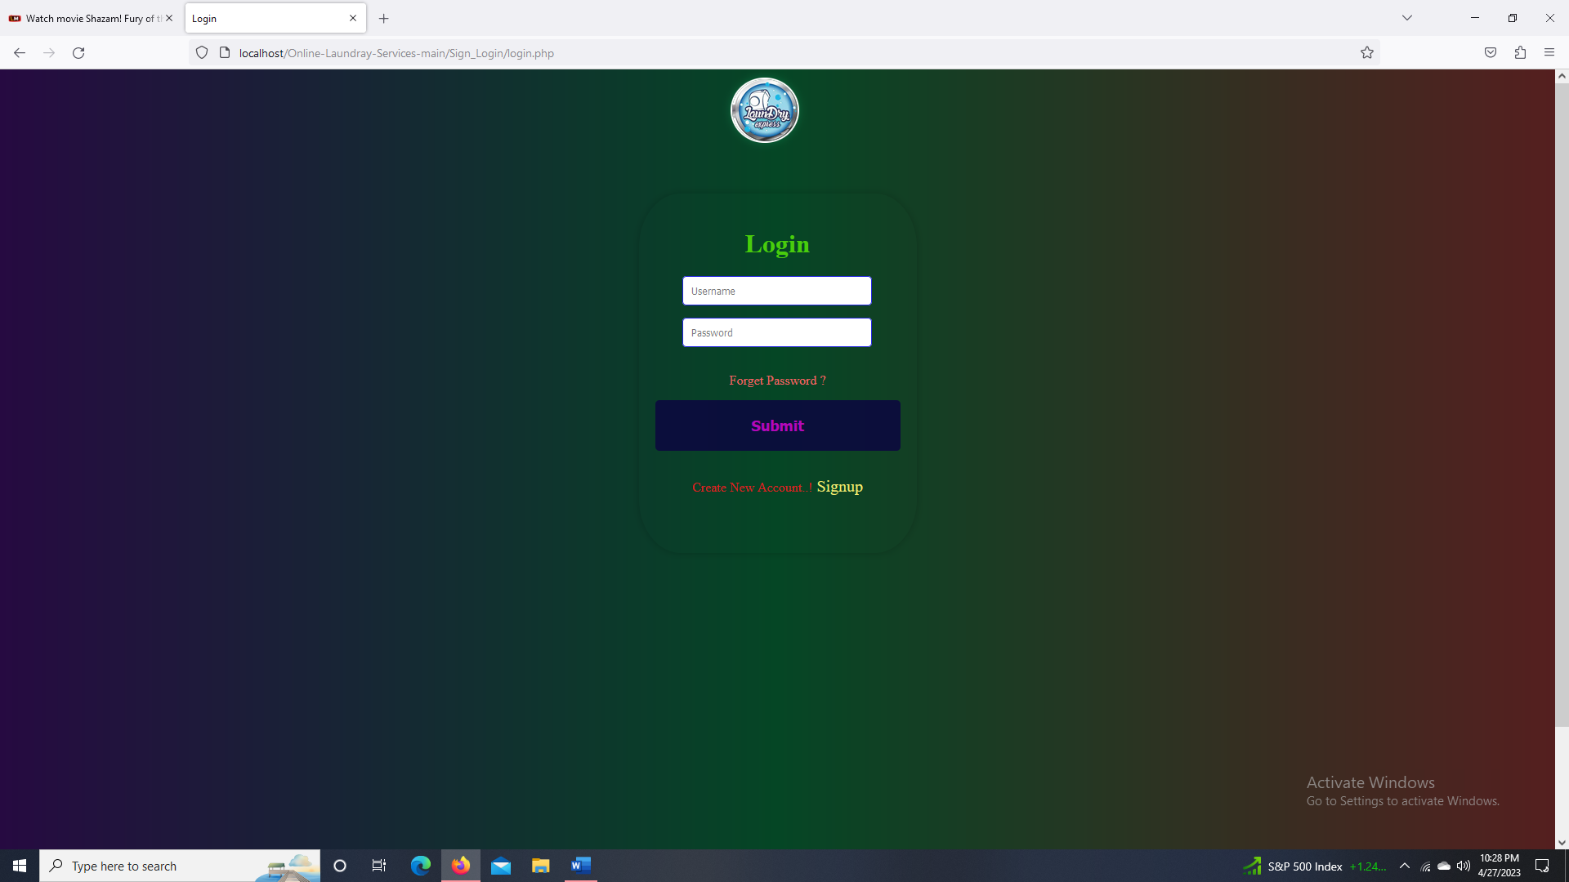

|  |  |  |  |  |  |
| --- | --- | --- | --- | --- | --- |
| Project Name: Laundry Express | | | Test Designed by: Ishtiak Ahmed | | |
| Test Case ID: FR_1 | | | Test Designed date: 02/05/23 | | |
| Test Priority (Low, Medium, High): High | | | Test Executed by: Ishtiak Ahmed | | |
| Module Name: Home | | | Test Execution date: 02/05/23 | | |
| Test Title: verify login with valid username and password | | |  | | |
| Description: Check Home Page | | |  | | |
| Precondition (If any): | | | | | |
| Test Steps | Test Data | Expected Results | | Actual Results | Status (Pass/Fail) |
| 1. Go to the website 2. Click links |  | Page should change to the link clicked | | As expected, | Pass |
| Post Condition: | | | | | |

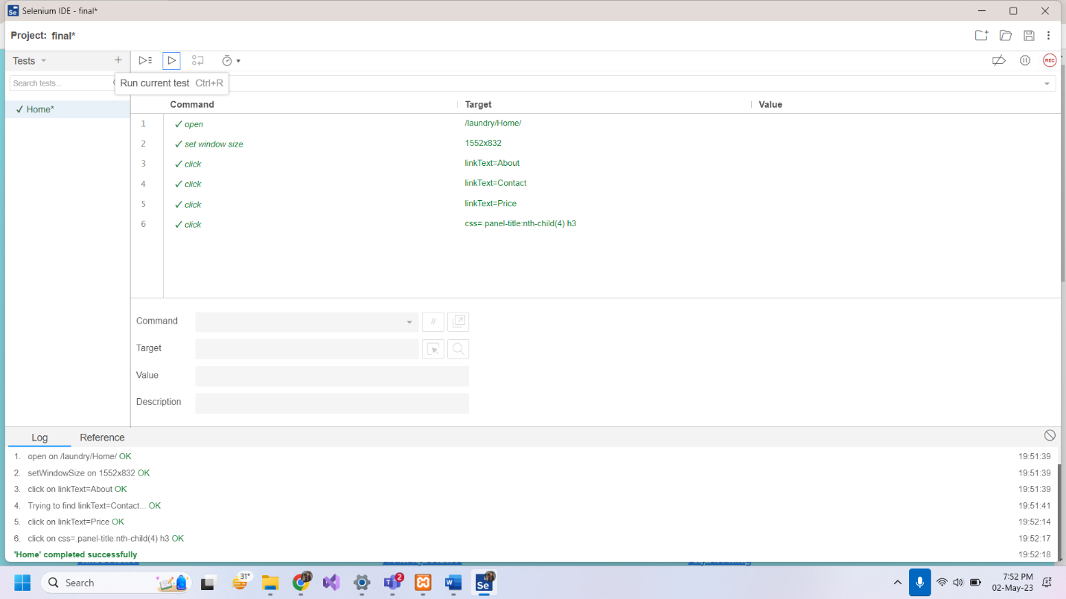

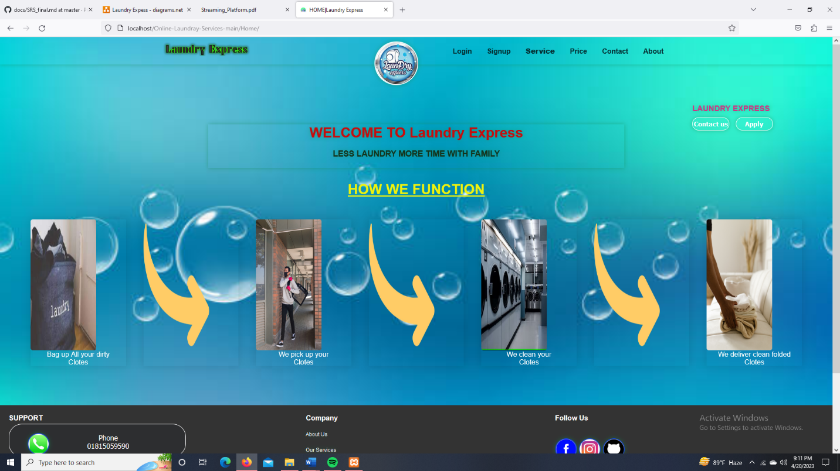

|  |  |  |  |  |  |
| --- | --- | --- | --- | --- | --- |
| Project Name: Laundry Express | | | Test Designed by: Ishtiak Ahmed | | |
| Test Case ID: FR_1 | | | Test Designed date: 02/05/23 | | |
| Test Priority (Low, Medium, High): High | | | Test Executed by: Ishtiak Ahmed | | |
| Module Name: Signup Session | | | Test Execution date: 02/05/23 | | |
| Test Title: Signup as Customer | | |  | | |
| Description: Signup with all given information. | | |  | | |
| Precondition (If any): | | | | | |
| Test Steps | Test Data | Expected Results | | Actual Results | Status (Pass/Fail) |
| 1. Go to the website 2. Enter username 3. Enter password 4. Click submit | Username: roy  Password: 123qw!@QW  Confirm Password: 123qw!@QW  Mobile: 01815059590  Email: p@gmail.com  Address: 647, South Thakurpara, Cumilla | After registering it should show the message resgistered successfully and take it to the login page. | | As expected, | Pass |
| Post Condition: | | | | | |

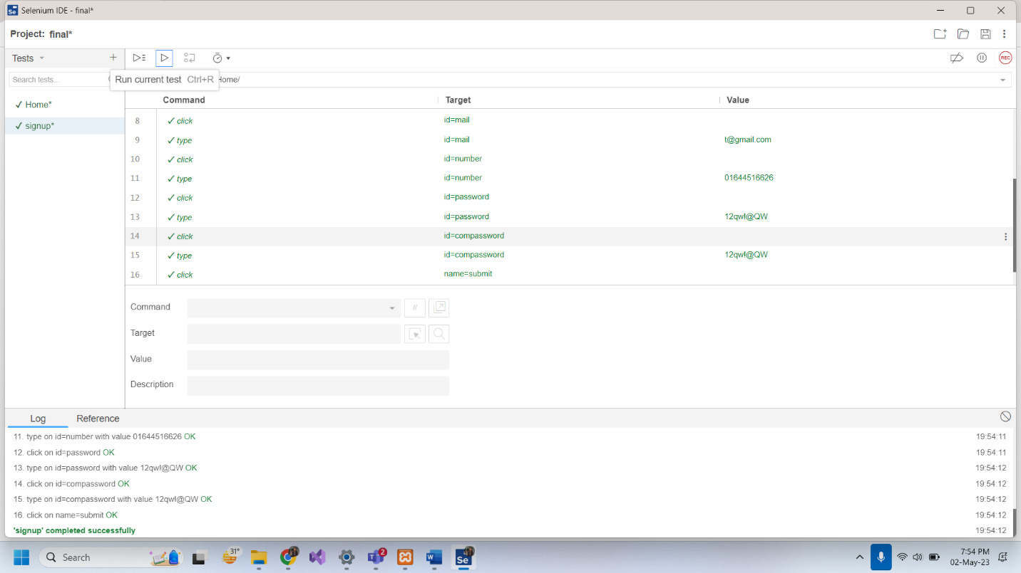

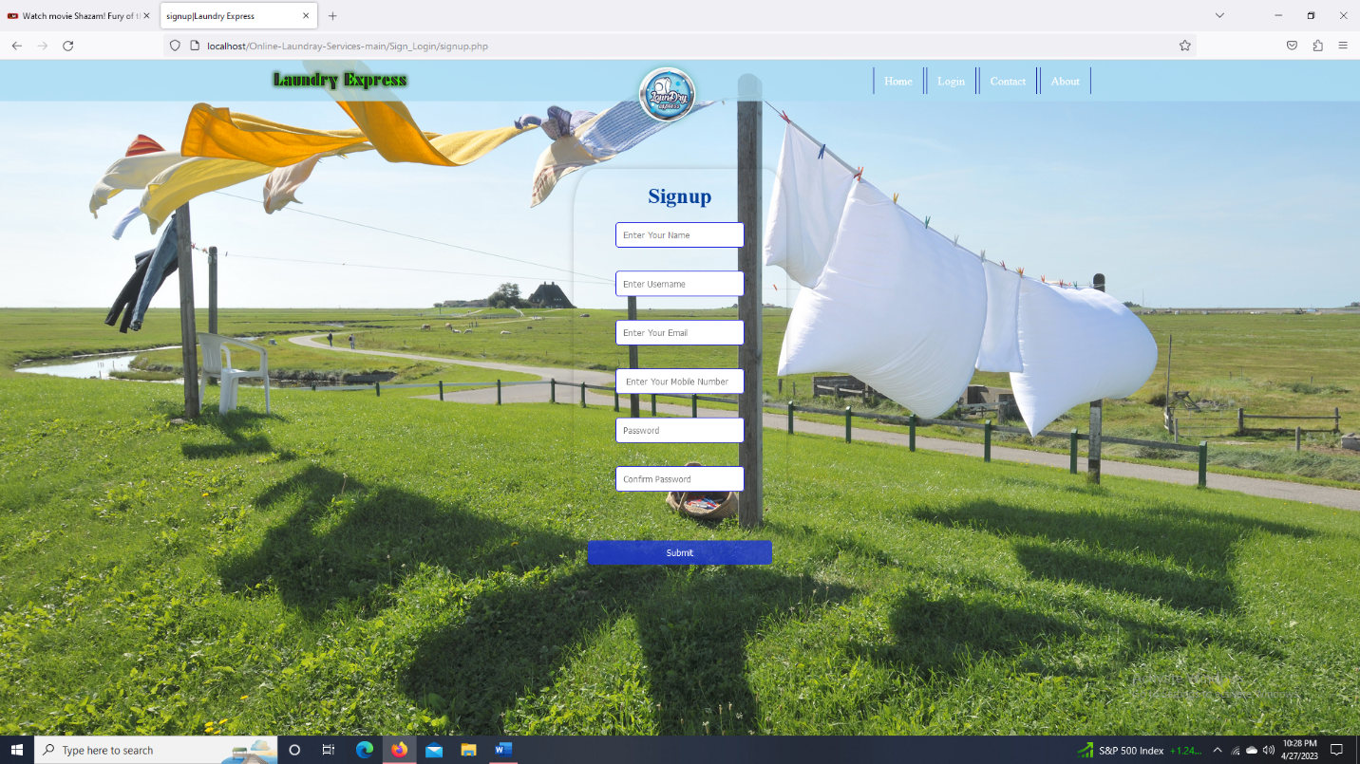

|  |  |  |  |  |  |
| --- | --- | --- | --- | --- | --- |
| Project Name: Laundry Express | | | Test Designed by: Ishtiak Ahmed | | |
| Test Case ID: FR_1 | | | Test Designed date: 02/05/23 | | |
| Test Priority (Low, Medium, High): Medium | | | Test Executed by: Ishtiak Ahmed | | |
| Module Name: Edit Profile | | | Test Execution date: 02/05/23 | | |
| Test Title: Check to change password, address, phone number etc. | | |  | | |
| Description: Should able to edit password, address, phone number etc. | | |  | | |
| Precondition (If any): | | | | | |
| Test Steps | Test Data | Expected Results | | Actual Results | Status (Pass/Fail) |
| 1. Go to the website 2. Click edit profile | Change information  Change password  Change address | After filling the info box click submit button and a message should show. | | As expected, | Pass |
| Post Condition: | | | | | |

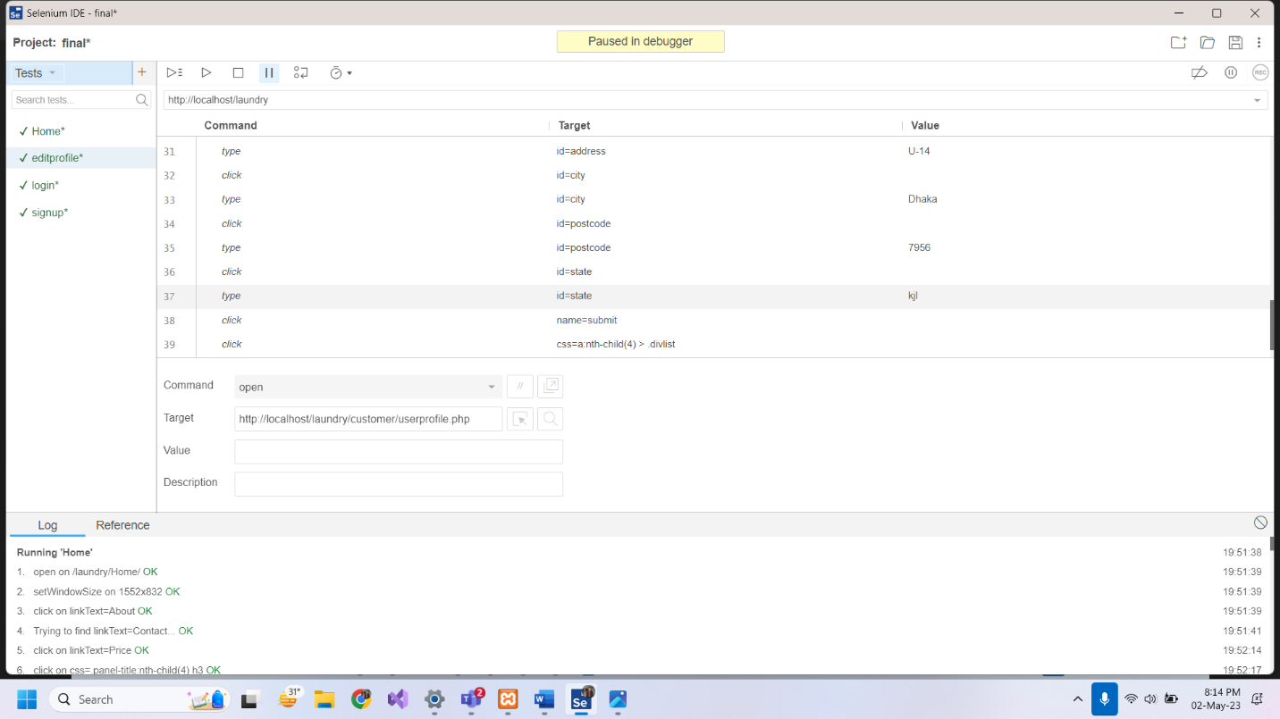

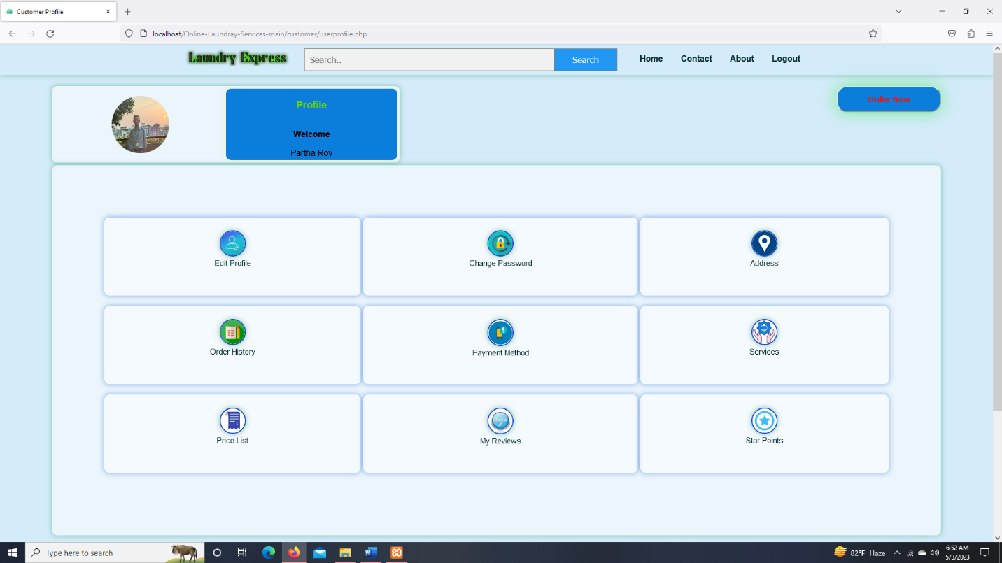

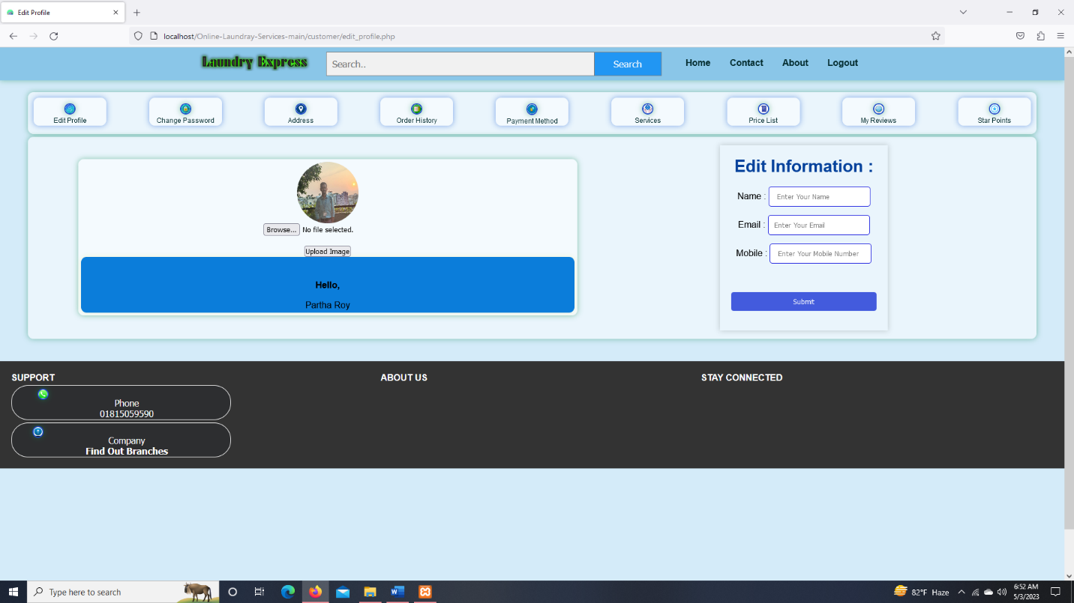

|  |  |  |  |  |  |
| --- | --- | --- | --- | --- | --- |
| Project Name: Laundry Express | | | Test Designed by: Ishtiak Ahmed | | |
| Test Case ID: FR_1 | | | Test Designed date: 02/05/23 | | |
| Test Priority (Low, Medium, High): High | | | Test Executed by: Ishtiak Ahmed | | |
| Module Name: Services | | | Test Execution date: 02/05/23 | | |
| Test Title: Add items choosing the appropriate service | | |  | | |
| Description: Should able to add item in specific services and submit to order. | | |  | | |
| Precondition (If any): | | | | | |
| Test Steps | Test Data | Expected Results | | Actual Results | Status (Pass/Fail) |
| 1. Go to the Profile 2. Click Order now/Service | Add items, fill up address, phone number etc. | Fill all the information and click submit. | | As expected, | Pass |
| Post Condition: | | | | | |

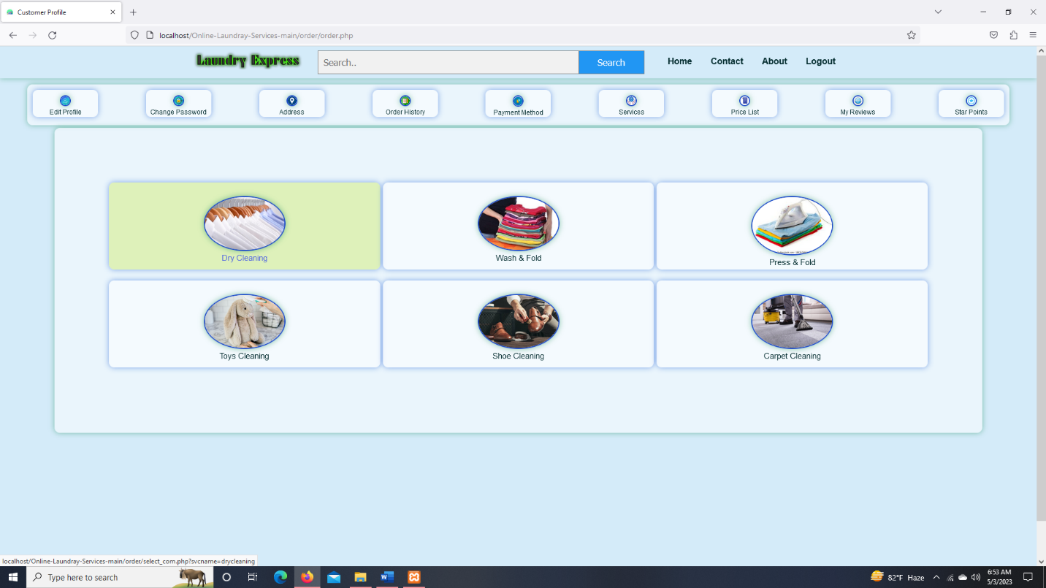

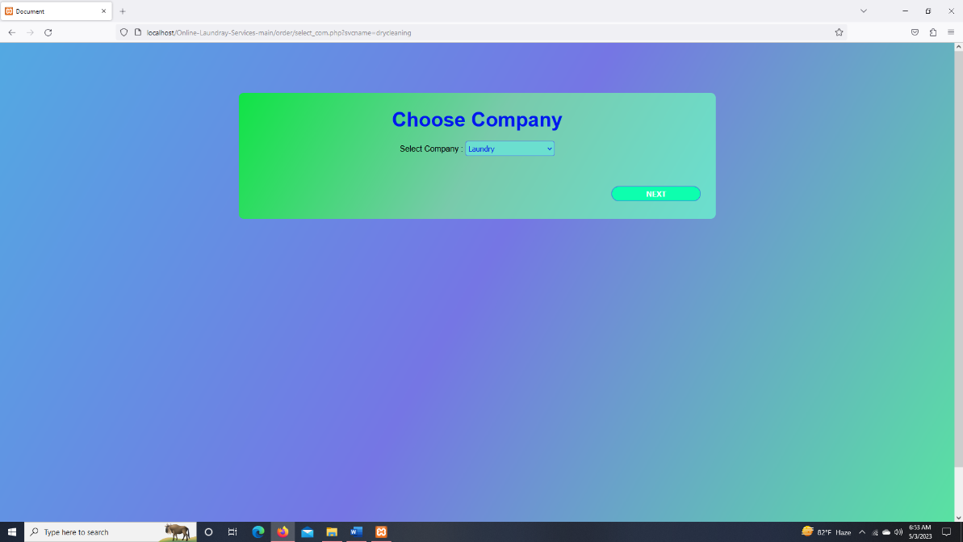

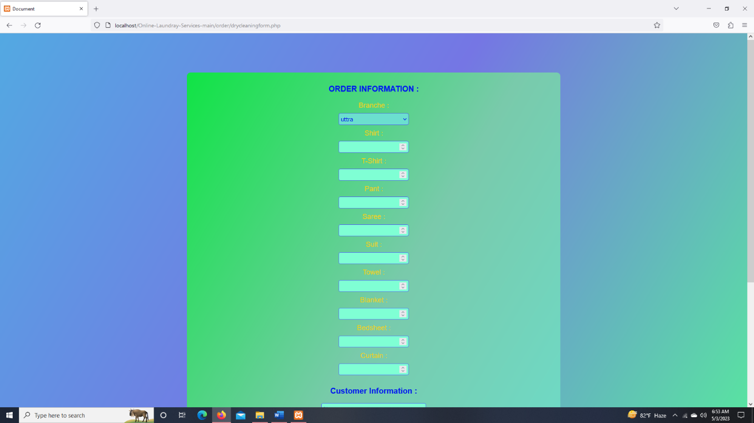

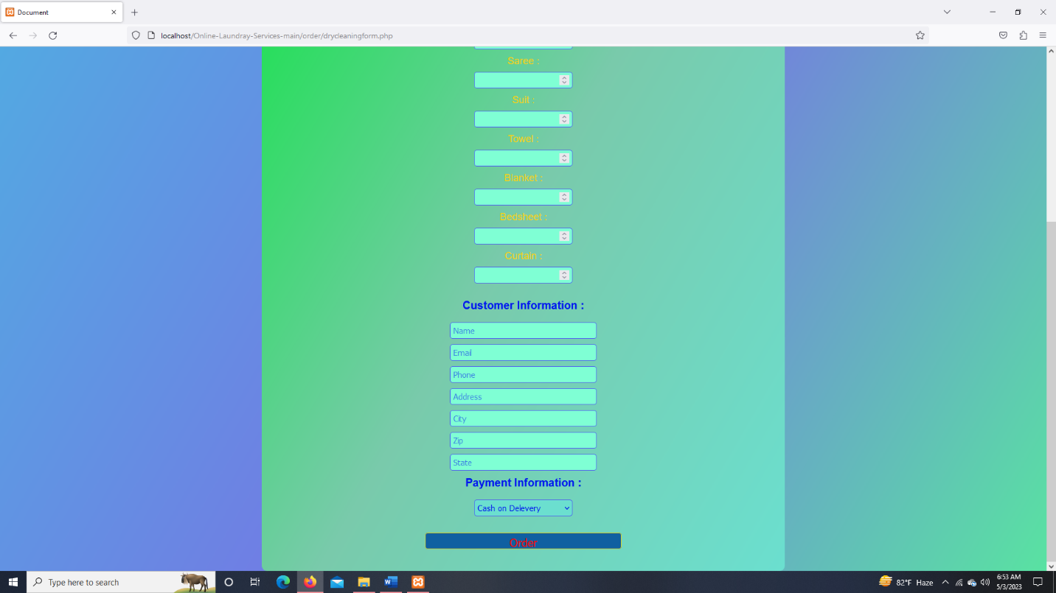

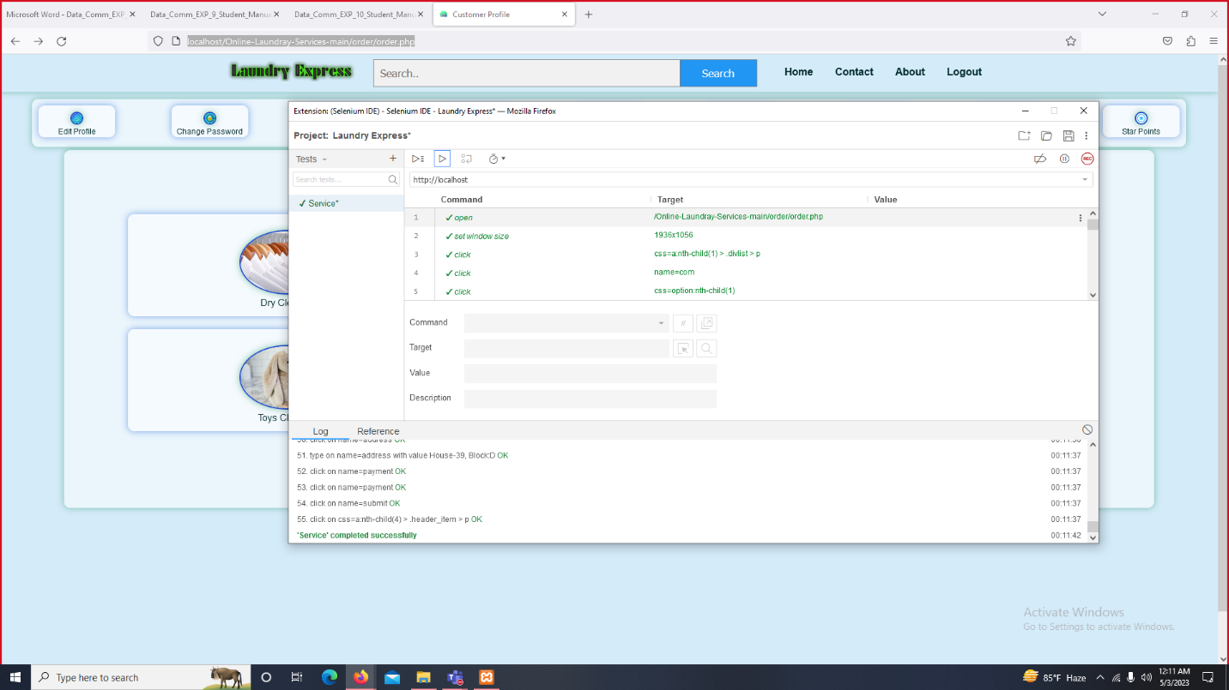

|  |  |  |  |  |  |
| --- | --- | --- | --- | --- | --- |
| Project Name: Laundry Express | | | Test Designed by: Ishtiak Ahmed | | |
| Test Case ID: FR_1 | | | Test Designed date: 02/05/23 | | |
| Test Priority (Low, Medium, High): High | | | Test Executed by: Ishtiak Ahmed | | |
| Module Name: Check Order | | | Test Execution date: 02/05/23 | | |
| Test Title: Check order made by the customer | | |  | | |
| Description: Able to check order made by the customer. | | |  | | |
| Precondition (If any): | | | | | |
| Test Steps | Test Data | Expected Results | | Actual Results | Status (Pass/Fail) |
| 1. Go to office employee Profile 2. Click check Order list |  | Click on check order list to see the order | | Not expected, | fail |
| Post Condition: | | | | | |

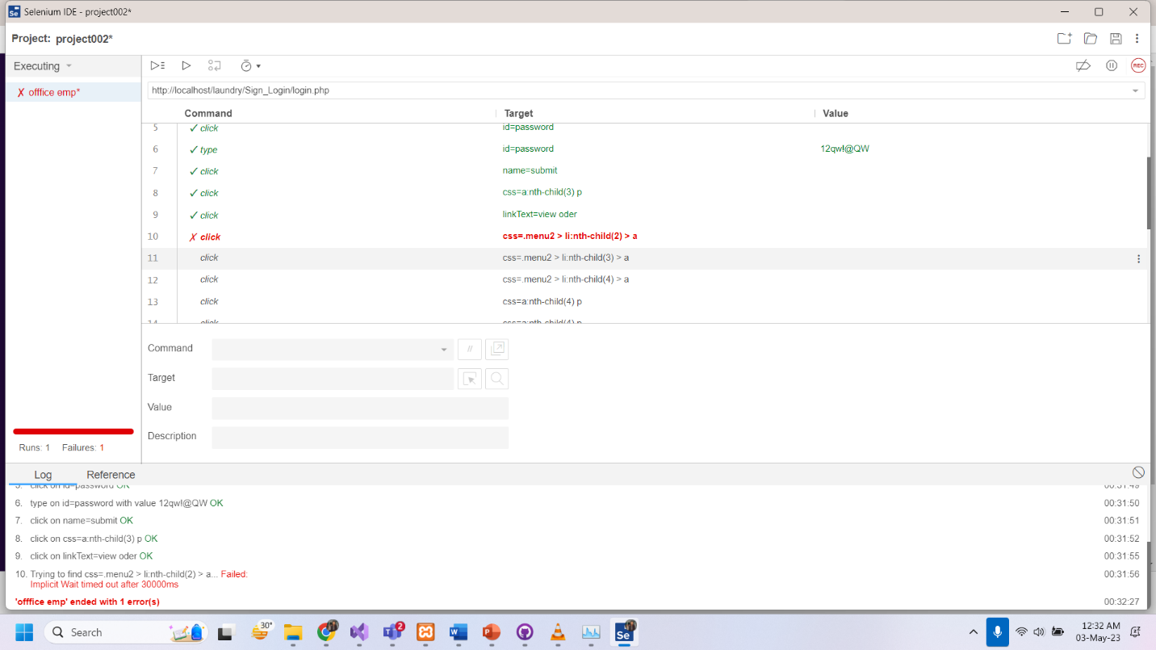

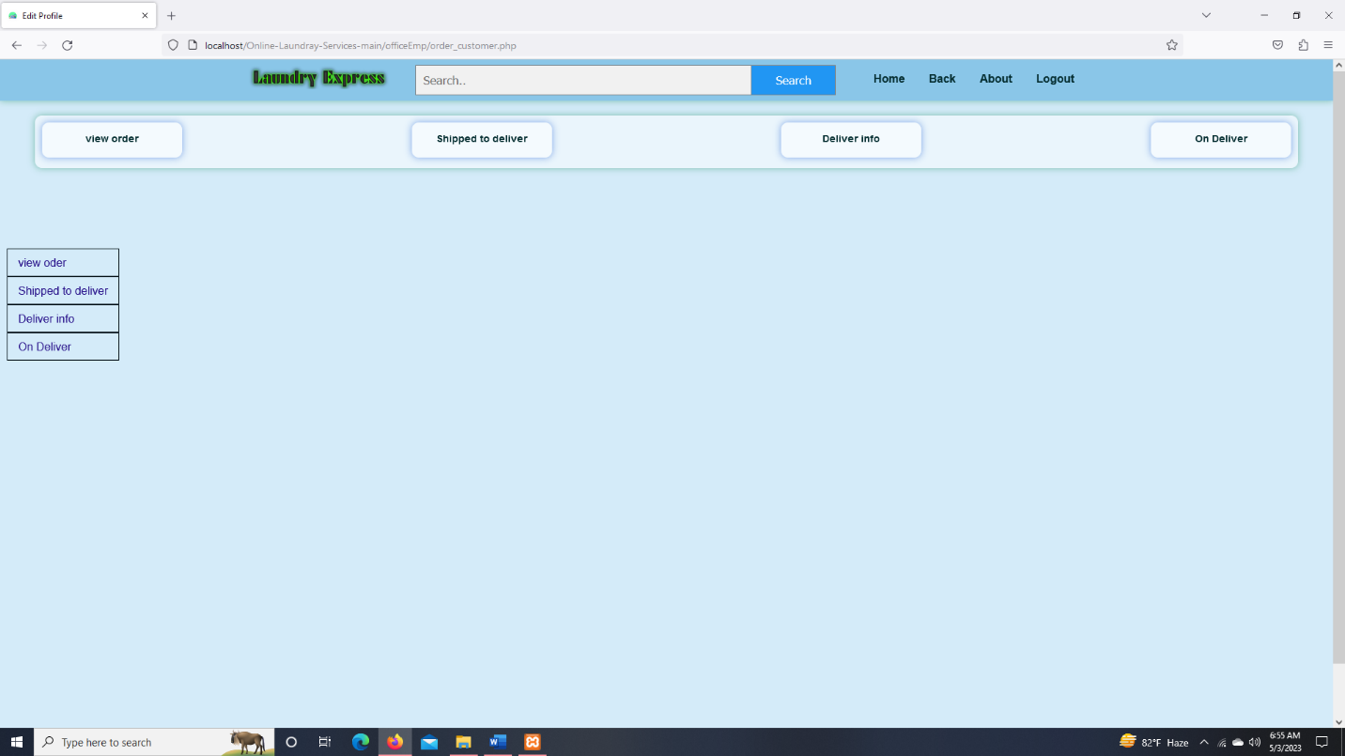

# ITEM PASS/FAIL CRITERIA

Software must be both reliable and high-quality. Achieving this requires implementing a thorough testing plan that includes clear pass/fail criteria. One of the most critical areas to test is the user registration process, ensuring that users can create accounts and log in seamlessly without any issues. The order placement process must also be tested to confirm that users can place orders and make payments without any errors or challenges. Furthermore, testing the platform's performance is essential to ensure that it can handle the expected traffic without significant delays or errors. Security is another key criterion that needs to be addressed, with the platform requiring protection against any unauthorized access and other security threats. Lastly, testing the platform's usability and compatibility across different browsers, devices, and operating systems is vital to ensure it is user-friendly and operates seamlessly. The platform passes the relevant tests if it meets the expected standards in these areas.

# TEST DELIVERABLES

Online laundry system, the following test deliverables are necessary to ensure the platform meets expected standards:

* System/Integration Test Plan: A document outlining the approach, objectives, and steps to be taken during testing of the integrated system components
* Unit Test Plans/Turnover Documentation: A set of documents outlining the testing approach, objectives, and steps to be taken during testing of individual units of code.
* Screen Prototypes: Prototypes of each screen in the platform that are used to verify that the platform meets the required design specifications.
* Report Mock-ups: Mock-ups of each report in the that are used to verify that the platform meets the required reporting specifications.
* Defect/Incident Reports and Summaries: Reports that document any defects or incidents found during testing, along with their severity and steps to reproduce them.

Reports: The testing process, including the steps taken, the results obtained, and the status of the platform after testing.

# STAFFING AND TRAINING NEEDS

To ensure the success of the online laundry system, proper training and staffing are essential. The staff should be trained on the system's features and functionalities, including customer service skills, order processing, and delivery procedures. The training should also cover health and safety guidelines, as well as proper handling and care of laundry items. Adequate staffing should be in place to handle the expected workload and to ensure timely delivery of laundry items to customers. Additionally, regular performance evaluations and training should be provided to keep the staff.

1. Laundry Operations Training: Staff members will need to be trained in laundry operations, including sorting, washing, drying, folding, and handling different types of fabrics.
2. Equipment Training: They should also be trained in how to use and maintain laundry equipment such as washing machines, dryers, and pressing machines.
3. Customer Service Training: Staff members will need training in customer service, including effective communication with customers via phone or email, addressing customer concerns, and managing expectations.
4. Technology Skills Training: Since it's an online system, staff members need to be familiar with the technology used by the online laundry system, such as the order management system, payment processing, and online scheduling.
5. Staffing Needs: The number of staff members required will depend on the volume of orders received and the services offered. For instance, a smaller operation may only require a few staff members to handle all aspects of the laundry process, while a larger operation may require additional staff for delivery, customer service, and management.

Overall, training and staffing needs in an online laundry system should focus on laundry operations, equipment, customer service, technology skills, and staffing requirements.

# RESPONSIBILITIES

|  |  |  |  |  |  |
| --- | --- | --- | --- | --- | --- |
|  | TM | PM | Dev  Team | Test  Team | Client |
| Acceptance test Documentation & Execution | 🗹 | 🗹 |  | 🗹 | 🗹 |
| System Integration test Documentation & Exec. | 🗹 |  | 🗹 | 🗹 |  |
| Unit test documentation & execution | 🗹 |  | 🗹 | 🗹 |  |
| System Design Reviews | 🗹 | 🗹 | 🗹 | 🗹 | 🗹 |
| Detail Design Reviews | 🗹 | 🗹 | 🗹 | 🗹 |  |
| Test procedures and ules | 🗹 | 🗹 | 🗹 | 🗹 |  |
| Screen & Report prototype reviews |  |  | 🗹 | 🗹 | 🗹 |
| Change Control and regression testing | 🗹 | 🗹 | 🗹 | 🗹 | 🗹 |

# TESTING SCHEDULE

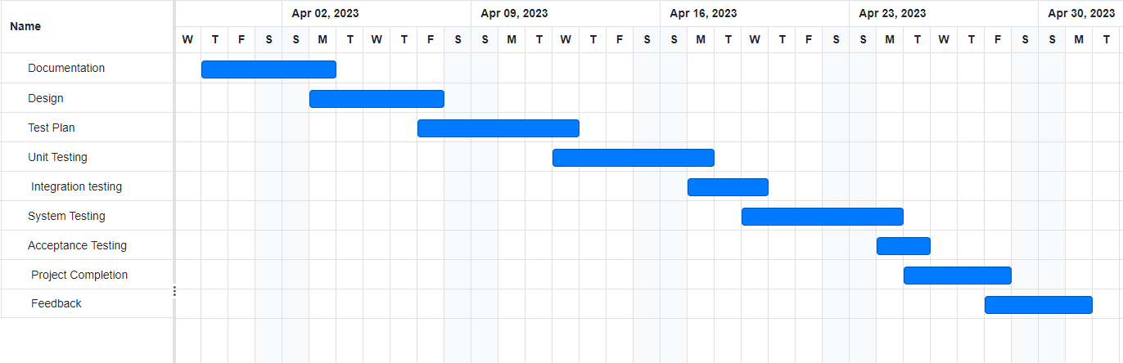

# PLANNING RISKS AND CONTINGENCIES

* Delays in identifying and resolving defects could lead to missing deadlines.
* The project may go over budget if extra resources are required to complete it.
* Inadequate testing could result in poor quality outcomes.
* Failure to understand the customer's needs may result in their not meeting their expectations.
* Insufficient security testing could pose security risks.
* In order to manage project risks, a quality assurance plan should be developed for software quality testing. A risk management strategy must be used to detect, assess, and mitigate risks during software quality testing. Consistent code reviews may assist in detecting potential issues.

# APROVALS

|  |  |
| --- | --- |
| Project Sponsor - |  |
| Development Management - |  |
| EDI Project Manager - |  |
| RS Test Manager - |  |
| RS Development Team Manager - |  |
| Reassigned Sales - |  |
| Order Entry EDI Team Manager - |  |